***MUI***

1. **.MuiAccordionSummary**  - root -- Styles applied to the root element.

2. .Mui**-expanded** - Expand -- State class applied to the root element, children wrapper element and IconButton component if expanded={true}.

3. **.MuiAccordionSummary-expandIconWrapper** -- expandIconWrapper -- Styles applied to the `expandIcon`'s wrapper element.

4. .**MuiAccordionSummary-expandIcon** --

5. **expandedPanel** -- As the expandedPanel state can have only the name of the clicked panel, only one panel will be expanded and for other false will be returned to collapse.

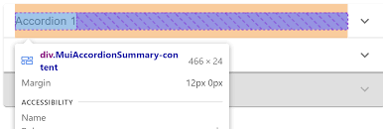

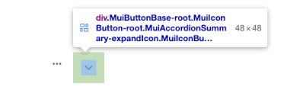

**6. .MuiTable-stickyHeader --** sticky styling, the table's rows and columns can be fixed so that they do not leave the viewport even when scrolled.

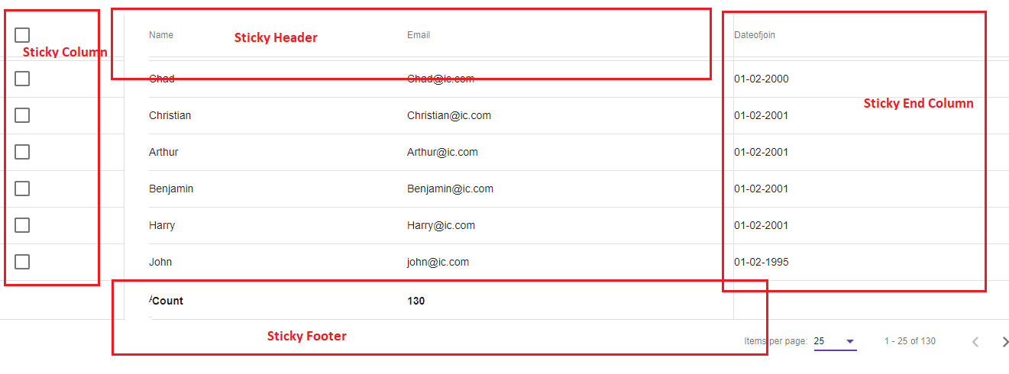

7. **.MuiTypography-gutterBottom** -- The name MuiTypography can be used when providing [default props](https://mui.com/material-ui/customization/theme-components/#default-props) or [style overrides](https://mui.com/material-ui/customization/theme-components/#global-style-overrides) in the theme.

8. **button[aria-label='search'] --**

